ALTAR SERVER TEAM PRE-MASS CHECKLIST - 15 MIN. BEFORE MASS

□ Who will assume the CROSS POSITION & associated duties?
- Carries the cross if cleared to do so by the priest or altar server coordinator. If not cleared – ask an usher to carry cross or inform the priest that usher is needed to carry cross
- Removes the book holder from altar & places it under credence table
- Removes the empty cup tray from the altar to the credence table immediately after Eucharistic ministers leave the altar for communion distribution (see picture (P2) on the backside of this handout)
- Assists priest by pouring the water from the water cruet into the chalice after communion & then removes the chalice from the altar to credence table

□ When an usher is needed to carry the cross for any procession – opening, offertory, recessional – the CROSS POSITION server notifies an usher or the priest and lets him know which procession(s) an usher’s assistance is needed.
- usher carries cross for all 3 processions if all servers at the mass have not been cleared to carry the cross by the priest or altar server coordinator
- usher carries cross at the offertory procession when there are two or less servers serving the mass (regardless of experience)
- usher carries the cross at the offertory procession if it is the judgment of the lead server that he/she (as the lead server) is needed to prepare the altar during the offertory because he/she is mentoring new servers

□ Who will assume the BOOK POSITION & associated duties?
- Holds the book for the priest at the beginning & end of mass – “Let Us Pray...”
- Places the book on the center of the altar in front of the chalice during offertory altar preparation (see picture (P1) on backside of this handout)
- Removes the Book from the altar to side table immediately after Eucharistic ministers leave the altar for communion distribution (see picture (P2) on the backside of this handout)

□ Who will assume the SIDE POSITION?

□ Which servers will prepare the altar during the offertory (see picture of a properly prepared altar on the back of this handout- P1)
□ The BOOK POSITION server places the book in center of altar & in front of the chalice.
□ Who will place chalice in the center of altar directly above the book?
□ Who will place all ciboria on altar in 2-3 vertical rows to the right of the book & chalice?
□ The lead server/priest/deacon will set the tray of filled cups on altar to the left of the book & chalice – remove the big rectangular white cover which is placed on top of all the filled cups and place it under credence table

□ Who will receive the gifts at the offertory with the priest?

□ Who will offer the priest the wine cruet?
□ Who will offer the priest the water cruet?

□ Who will offer the priest the bowl & water pitcher?
□ Who will offer the priest the towel?
□ Does priest have any special instructions? Is there deacon or another presider?
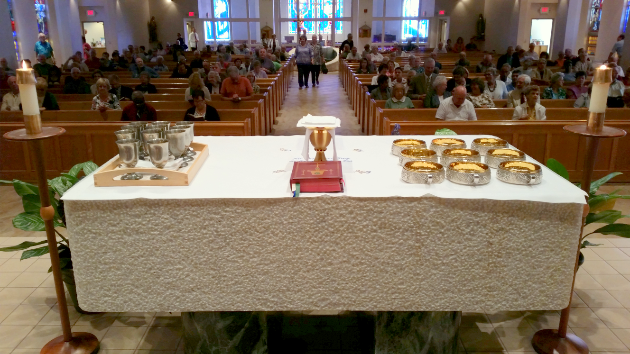
(P1) A PROPERLY PREPARED ALTAR DURING OFFERTORY

√ The lead server/priest/deacon places tray of filled cups on altar to the left of the book & chalice - remove rectangular cover & place under credence table
√ The BOOK POSITION SERVER places the book in center & in front of chalice on altar
√ Designated server places chalice in center & above the book on altar
√ Designated server(s) places ciboria in 2-3 vertical rows to the right of the chalice & book

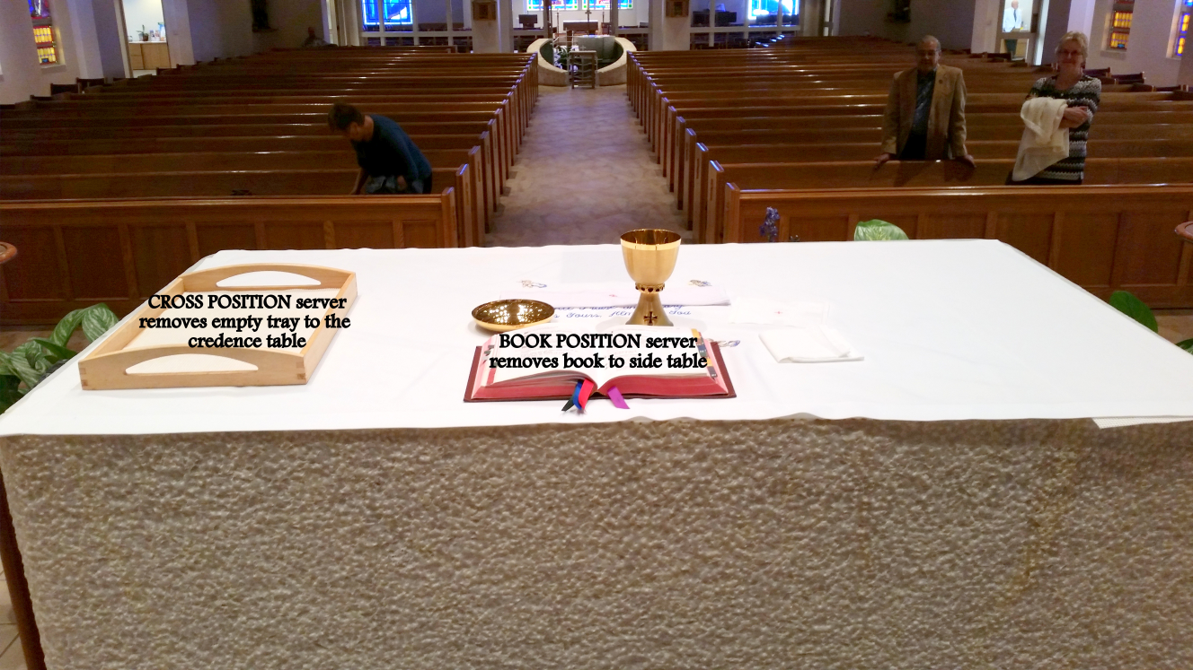
(P2) PICTURE OF ALTAR WHEN PRIEST & EUCHARISTIC MINISTERS LEAVE ALTAR FOR COMMUNION DISTRIBUTION

